\*\*Math library returns DOUBLEs (except for Math.round() & Math.abs() which return LONGs)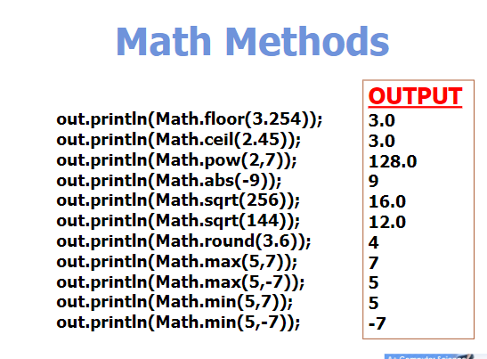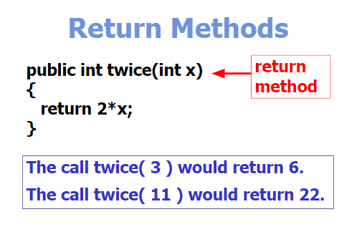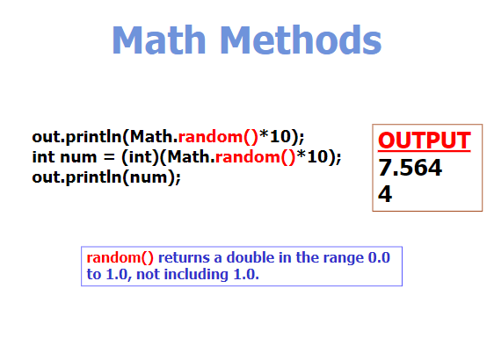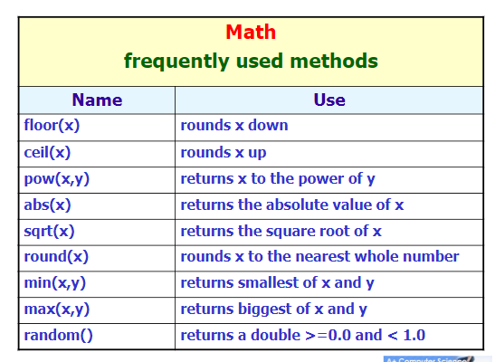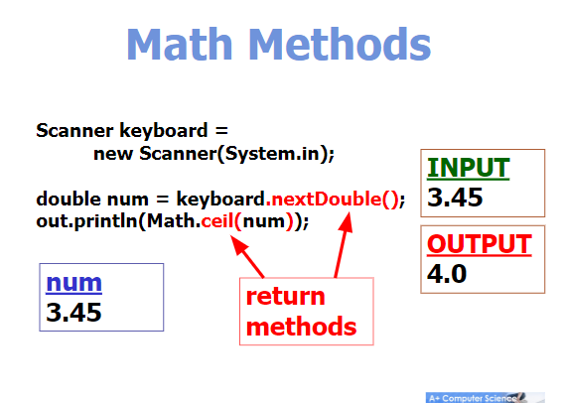

\*\*for a chance interval between (lowerBound,upperBound) or probability(lowerBound <= x <= upperBound) use: **(int)(Math.random() \* upperBound) + lowerBound**